5.43: Setting 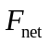 equal to the maximum tension in Eq. (5.17) and solving for the speed v gives
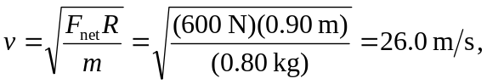
or 26 m/s to two figures.

